Dimensions:
L1 - total body length | mm
L2 - brush working part | mm
H1 - pile height | mm
H2 - body height (not less than 10 mm) | mm
W1 - body width | mm
Housing material (plastic / wood) or others.
Required number of | pieces
Order form flat brushes Stuffing
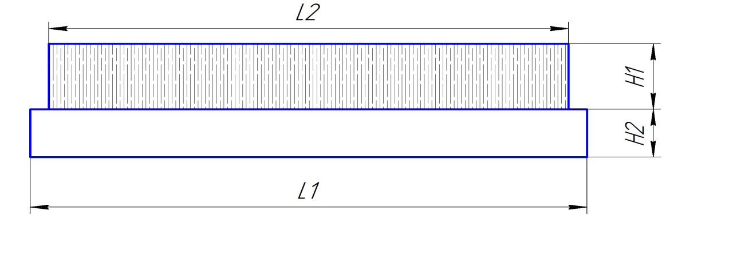
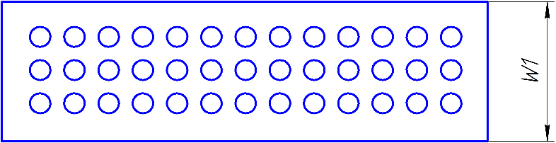
parameters: Stuffing
type | No.
A- distance from the edge of the base to the hole | mm
E- distance from the edge to the hole | mm
B1 - step of packing horizontally | mm
B2 - step of stuffing vertically | mm
D - diameter of the hole | mm
Diameter of the pile | mm
Material of the pile (polyamide , polypropylene, PET, natural horse hair)

