Dimensions:
L1 - total shaft length | mm
L2 - brush working part | mm
Base material
H1 - pile height | mm
Nap thickness | mm
Nap material: (polyamide, polypropylene, PET, natural horse hair, natural pork bristle)
D1 - inside diameter of the body | mm
D2 - outer diameter of the case | mm
D3 - outer diameter of the brush along the pileStuffingStuffing | mm
Environment of use
Required quantity | pcs
Order form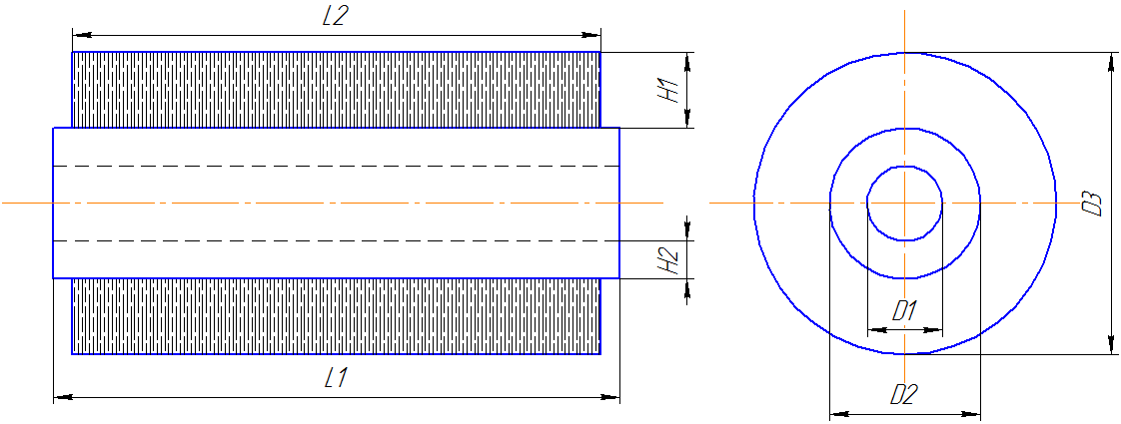
parameters:
type | No.
A - distance from the edge of the base to the hole | mm
B1 -horizontally | mm
stacking stepB2 - stacking step vertically | mm
D - hole diameter | mm
Number of approaches (if the packing is spiral) | pcs
Distance between turns (if the packing is spiral) | mm

